SNAP Metrics Manual

USDS - January 2025

# Introduction

The purpose of this manual to discuss the definitions of time to process (TTP) and average outstanding time (AOT), make notes on monitoring these two metrics, and finally to present some common scenarios to help interpret what these metrics might be saying about the processing of client submissions. This manual is meant to be a reference in the implementation and usage of these metrics.

There are a number of applications for these two metrics including:

* understanding where bottlenecks exist​
* prioritizing investigation and intervention areas​
* understanding the impact of interventions before and after they are in place​
* having ongoing measures of improvement, regression, and a way to identify further opportunities​

# Metrics

The USDS proposes the use of two metrics for monitoring program health to ensure that clients are experiencing the least amount of burden and time spent waiting as possible, and to minimize the size of the state’s backlog and maximize efficiency. Because these metrics can be used to measure a client’s application, recertification, or client-submitted report, in all the definitions below we refer to any of these as a client’s *submission*.

## Time to process (TTP)

The average *time to process,* or TTP, is the average length of time from the moment the state receives a client's submission until the moment processing has been completed and the client’s eligibility has been determined.​ TTP is measured in units of time (for example: the average number of hours or days it takes to process SNAP applications at a point in time).

### How does TTP compare to APT?

While TTP is similar to application processing timeliness (APT), there are several important distinctions.

|  |  |
| --- | --- |
| **Time to Process (TTP)** | **Application Processing Timeliness (APT)** |
| ⨯ Not currently required by FNS | ✓ Satisfies FNS reporting requirements |
| ⨯ Doesn’t measure open cases | ⨯ Doesn’t measure open cases |
| ✓ Measures applications, recertifications, and client-submitted reports | ⨯ Only measures applications |
| ✓ Measures approvals and denials | ⨯ Only measures approvals |
| ✓ Measures the exact amount of time | ⨯ Only distinguishes between “timely” and “untimely” |
| ✓ Measures continuous, unlimited improvement | ⨯ Bounded by 0% and 100% APT |
| ✓ Oriented towards lived client experience | ⨯ Oriented towards compliance |

A few of these differences are notable:

* APT failing to measure the time it takes to process denied submissions has the potential to lead to unfair or biased program processes.
* APT requires categorizing submissions as either “timely” or “untimely”. This means that non-expedited applications processed in 3 days versus those processed in 29 days are seen to have exactly the same outcome. Similarly, non-expedited applications processed in 31 days and those processed in 180 days are also seen to have the same outcome, despite these being very different outcomes for the client.

As TTP is a time interval, it is also important to be precise about when this interval begins and when it ends. The time interval for TTP always **begins at the moment the client’s submission is received by the state**. However, depending on the outcome of processing, the end of this interval varies. In the case that an application or recertification is approved, the interval ends at the moment of approval. In the cases where the submission is denied, the interval ends either at the moment when the client is determined ineligible (an explicit denial), or in the case where more information was needed and the client failed to respond, the interval ends when at the moment that state has determined a failure to respond (a procedural denial).

TTP is a crucial metric because it reflects the client’s actual lived experience for how long their submission took to be processed, and therefore in part measures the administrative burden placed on that client.

### How do I calculate TTP?

It is recommended that TTP be calculated for the following categories of client submissions:

* Expedited applications
* Non-expedited applications
* Recertifications
* Client submitted reports

The formula for TTP for a single submission is below:

|  |
| --- |
| ***TTP = Time submission processing completed – Time submission sent*** |

## Average outstanding time (AOT)

The average outstanding time, or AOT, is the average length of time client submissions have been open. This only includes submissions that have not yet been completed or eligibility not yet determined, and begins from the moment the submission was received.​ AOT is also measured in units of time.

### How does AOT compare to TTP?

AOT is only relevant to submissions that have not yet been completely processed, and it can be thought of as partial or in-progress TTP. It is important to measure AOT in conjunction with TTP because TTP is inherently biased towards submissions which are processed to completion. In an ideal scenario, all submissions are processed to completion, but this is not necessarily true in practice, nor is it true when looking at a moment in time. For this reason, TTP may give the impression that client submissions are being processed quickly, while in fact only *some* submissions are being processed quickly, while others might be stuck in processing or might be being ignored completely. Monitoring AOT would allow this situation to be caught and correctly quickly, because TTP would be seen to be steady or improving, while AOT would be rising.

### How do I calculate TTP?

It is recommended that AOT be calculated for the following categories of client submissions:

* Expedited applications
* Non-expedited applications
* Recertifications
* Client submitted reports

The formula for AOT for a single submission is as follows:

|  |
| --- |
| ***AOT = Current time – Time received*** |

Note that this is easily calculable for past times as well; the AOT for a submission on date X is (X – time received), assuming that the submission was still open at time X.

# Monitoring

We define daily TTP as the average TTP of all submissions in which processing was completed within a given day (regardless of when the submission was received). We define weekly TTP similarly as the average TTP of all the submissions in which processing was completed within a given week. While TTP will likely fluctuate too much day to day to make day-over-day comparisons particularly useful, week-over-week TTP comparisons should be useful, especially for the purpose of establishing trends.

AOT is best used in comparison to the current week’s TTP and in comparison to the previous week’s AOT. AOT should be proportional to TTP each week – if TTP has been trending up, AOT should also be trending up, and vice versa. When this is not the case, it may be cause for alarm, particularly in the case where TTP remains steady or trending down, and AOT is trending up. This scenario may indicate that some submissions are trapped at the bottom of the pile and are continuing to age without being closed out.

We therefore recommend monitoring week-over-week TTP for trends, and comparing AOT to the current week’s TTP, recent TTP trends, as well week-over-week AOT.

# Interpreting the data

In this section we will present several hypothetical scenarios to help illustrate how these metrics might be used to draw conclusions about the health of the SNAP program, and how they might inform next steps. As mentioned above, there will be small fluctuations in TTP and AOT over the course of time, and these variations may not be enough to be cause for concern. It will be helpful to set thresholds for these metrics based on a combination of how much these metrics fluctuate on average and risk tolerance.

## How will I know we’re trending in the right direction?

Because both TTP and AOT relate to how long clients spend waiting for a decision, we want to see both TTP and AOT either decreasing or steady over time. As mentioned above, we expect TTP and AOT to fluctuate with time, and minor changes might be observed with little or no meaning, and large changes may be observed if something somewhat anomalous has occurred. Therefore, we’re generally more interested in trends rather than specific values of TTP and AOT. The following scenarios are designed to dig deeper into what might be happening when the metrics aren’t performing ideally, and to explore what the next steps might be.

## How should I look out for “warning signs” that something needs attention?

## Scenario 1: A sharp upwards spike in TTP

There is a large increase in TTP this week compared to last week.

**How do we define large?**

Unfortunately, there’s no one-size-fits-all solution to this question. States with smaller numbers of staff will generally experience higher fluctuations in TTP week-over-week than programs with large numbers of staff. Some states may also have more regular or more seasonal patterns to when they receive client submissions. These are some examples of thresholds the state can set for when they should be alarmed. There will likely need to be some calibration on these thresholds as TTP is collected over time, and the state will likely want to use some combination of these rather than just one.

* A large spike might be a flat percentage higher week over week (for instance 20% higher than last week).
* If the state compares differences in TTP from week to week, this week’s difference may rate above a certain threshold (see the example below). For instance, these thresholds might be:
  + A high percentile of differences (for example, above the 80th percentile)
  + One or more standard deviations above the mean difference

**What might be the cause?**

In the absence of an unusual event that triggered the change in the metrics, it could be case that recent policy or process changes have increased the time it takes to process. For a change this large, it would likely be a recent or high impact change.

**What data should we look at next?**

* Is this week’s AOT also exhibiting an upward trend? This could indicate submissions are indeed taking longer. If AOT is trending even or decreasing, the rise in TTP may have just been a temporary fluctuation. If AOT has also spiked up, there is a much higher chance a recent change is affecting processing times.
* Have there been any changes to policy or processes that could explain these changes?
* Is the volume of submissions similar to what’s normally seen at this time?

### Example

As mentioned above, it’s important to be able to determine when a spike is large enough to warrant additional investigation. This example will demonstrate how to make this determination. Below, we see an example of TTP plotted as a line graph with hypothetical data. In this example, we use weekly TTP, but this example can apply to any time period. We also see that TTP is generally trending down, with a large upward spike between weeks 9 and 10, though weeks 9 and 10 have neither the highest nor lowest weekly TTPs within the timeframe.

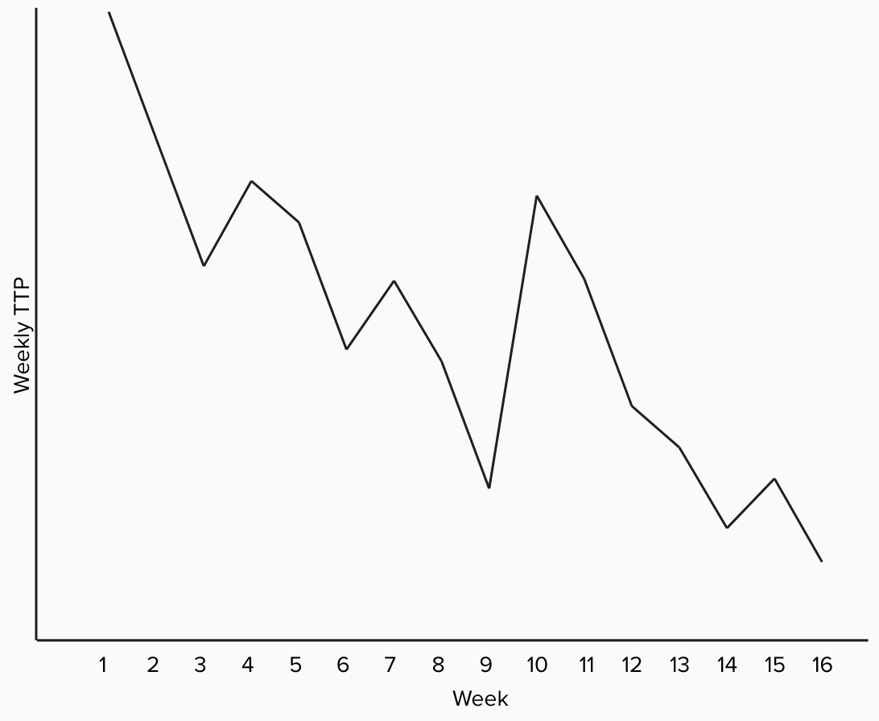

If we reorganize this same data into a waterfall chart, we get the chart below, depicting drops in TTP in blue, and increases in red. Each bar represents the difference in weekly TTP between each of the weeks. Again we see the difference between weeks 9 and 10 as the largest bar, but is this a large enough difference to be a cause for concern?

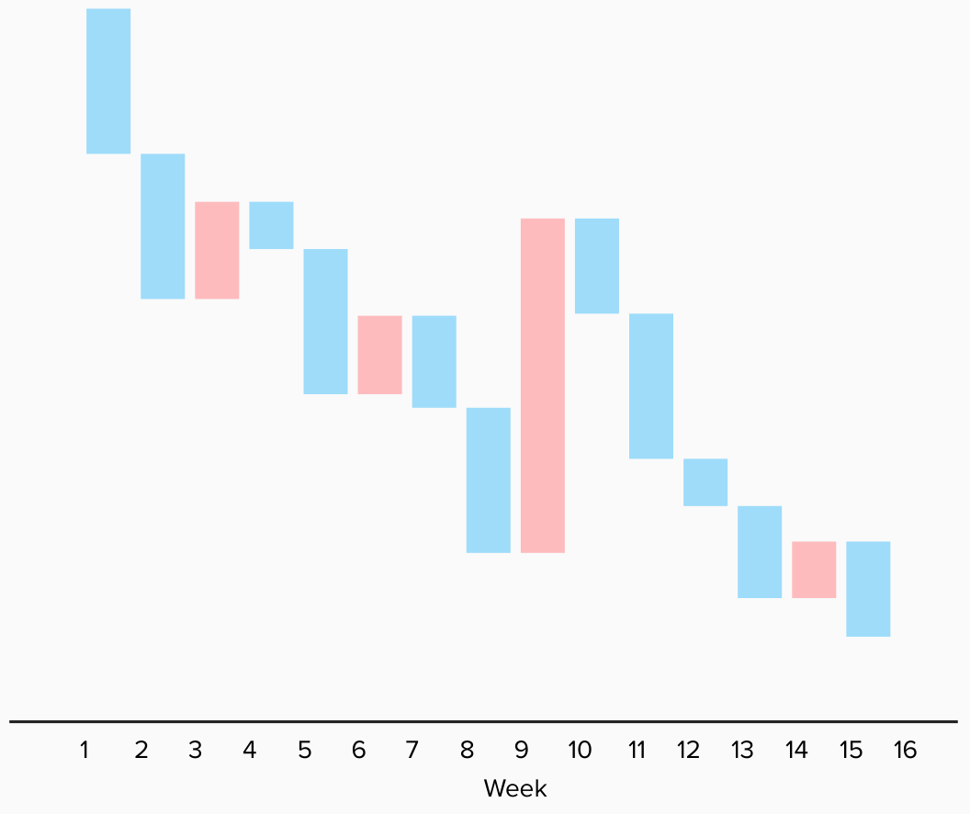

We are interested in comparing the difference in question against all historic differences to determine whether this is more likely a typical fluctuation or closer to an outlier. As mentioned in the section above, this threshold can be set in a number of ways, including using percentiles or standard deviation among all or recent historical differences.

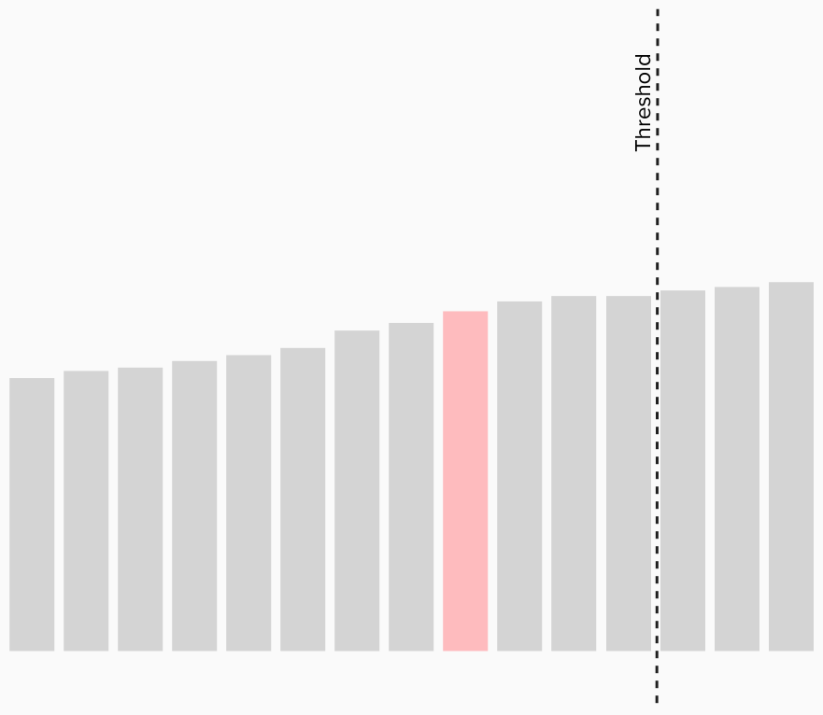

Above we make this comparison against all historic differences (positive and negative) and see that the jump from week 9 to week 10 is actually below our threshold, and not necessarily a major cause for concern. This can happen when there is a larger fluctuation among a number of smaller fluctuations, and is why it is important to perform this type of analysis over a simple comparison within a limit timeframe.

## Scenario 2: A sharp downwards spike in TTP

There is a large decrease in TTP this week compared to last week. We can reuse the methodology above to define large in this case. Generally, a large decrease in TTP is considered good – but only in the context that there is a clear reason for this decrease. A significant decrease with no corresponding change could likely indicate an issue with data collection or quality. Note that although the downward spike may be recent, the data quality issues might not be, and may require a deeper audit into data practices and ensuring that no submissions are being filtered out or counted multiple times.

## Scenario 3: Sustained upward trend in TTP

There have been relatively small increases in TTP week over week for a several weeks, or TTP spiked up one week but as remained at the elevated rate for a few weeks.

**What might be the cause?**

A sustained increase in TTP is the most concerning of these scenarios. If the increase has plateaued it is likely a recent change caused an issue and the increase is the change’s direct effect on TTP. If TTP is still rising, the full effect has not yet been realized, or the issue is compounding.

**What data should we look at next?**

* Has AOT been increasing proportionally during this time? If so, we can likely expect TTP to continue rising. In the unlikely scenario AOT has remained flat or been decreasing, we have less signal and further investigation may be needed.
* Assuming no changes to policy, process, or volume of submissions, there could be a possibility some external changes, such as changes to dependent software or delays in mail or client responses. It would be good to try to isolate which part of the process has been slowed down in order to investigate further.

## Scenario 4: AOT trending in a different direction from TTP

This scenario encapsulates when TTP is trending up and AOT is low or trending down, or when TTP is flat or decreasing and AOT is high or trending up. If TTP and AOT are both trending down, this is generally good (assuming it maps to a recent change and is expected). TTP and AOT both trending up is covered in Scenario 3.

### Example

Below is an example of TTP and AOT trending in different directions. TTP is clearly trending down, while AOT it clearly trending up. Note that while both visualizations use days as the vertical axis, they aren’t necessarily the same scale.

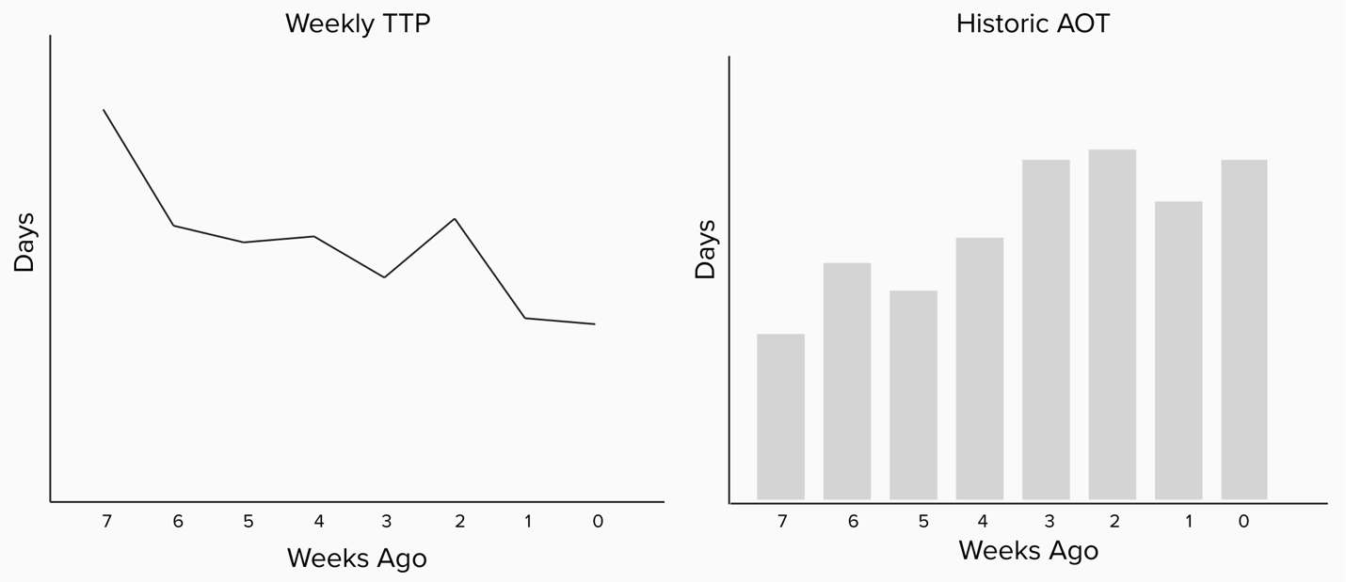

**What qualifies as disproportionate?**

As with the discussion of what qualifies as a large spike in Scenario 1, the state will have to determine what crosses the threshold of what is disproportionate. In the most common scenario where the open submissions are relatively well distributed, we would expect the AOT to be approximately 50% of the current TTP. Setting a threshold of something like AOT is 75% of TTP may be appropriate. In states where submissions are cyclical, there may have to be a predictive correction applied on top of this (for example maybe submissions in your state spike 300% between December and January every year – this would have to be accounted for in the threshold).

**What might be the cause?**

If a new change has been introduced recently and AOT is changing while TTP has not, it may indicate the change is increasing processing time and that TTP is going to change to follow suit.

**What data should we look at next?**

* Has there been a recent change?
  + What parts of the process does this change effect?
  + Have those parts of the process increased in complexity or length?
* Is the state processing submissions uniformly? For example, if the newer submissions are being processed first over older ones, older submissions may be being pushed down further and further at the bottom of the pile, dragging down AOT but keeping TTP even.

## Scenario 5: Sustained upward trend in AOT

In this scenario we observe AOT trending up week over week, but TTP is remaining flat or decreasing.

**What might be the cause?**

Assuming AOT continues to trend down, this is likely the scenario as mentioned above where newer submissions are being processed first over older ones and older submissions may be being pushed further and further down the pile. Because new submissions are presumably being processed at the usual rate, we see no change to TTP, but some submissions are staying open for longer and longer, dragging down AOT which is calculated as an average.

**What data should we look at next?**

* Are all submissions being affected equally week over week? What does the distribution of open submissions look like over time?
* Why might older submissions still be staying open?
  + What is keeping them open longer than usual?

# Frequently Asked Questions

## How should we be thinking about past or point-in-time AOT?

AOT is essentially partial TTP, or the TTP of submissions which have been partially processed. It is generally meant to be used as an proxy for future TTP. As a result, it can be difficult to reason about AOT at points in the past. The AOT from any particular week five years ago can be recorded or calculated, but those submissions have already been fully processed, meaning that we no longer need a proxy for TTP when we already know definitively. Comparing trends between past snapshots of AOT are helpful as we highlighted in the examples above, but generally speaking it's more useful to consider TTP when thinking about the past and present, and AOT when thinking about the present and future.

## TTP and AOT give us a really granular way to track how we process submissions. Can we use it as a performance metric for eligibility staff?

Unfortunately, no. There are three main issues with this.

As discussed above, TTP and AOT are meaningful in the aggregate and for comparing trends. We expect TTP to have a very high variance, meaning that the smaller the sample size, the less confidence we can have in the actual processing time meaning something specific and concrete. Especially when considering the TTP or AOT of a specific person processing submissions, there are any number of reasons their time to process might be different from a colleague's. This brings us to our second point, incentive alignment.

Evaluating individual performance of staff via TTP and AOT is likely to reward behavior we don't want, and to punish behavior we do. Processing submissions faster is a virtue insofar as it does not cause more errors or encourage unnecessary risks. It is often common practice to assign more difficult cases to more experienced staff members. More difficult cases take longer to process, meaning that the most valuable staff members may be rated among the lowest performers. In the context of AOT, workers should be strongly encouraged to work the oldest cases first. Measuring them on how low the AOT of their cases is creates a perverse incentive to play "hot potato" with old cases instead of completing them as soon as possible.

Finally and perhaps most significantly, TTP and AOT are designed to measure program performance, not individual performance. For example, the choice to include the time it takes verifications to be mailed to clients, received, filled out, and returned to the state are all included in TTP, because it incentivized the program to make more careful choices about how often to send mail and ensuring that forms are easy to understand, fill out, and return. This does not provide any meaning about the efficiency or effectiveness of the worker assigned to the case.

The need to track staff performance is real, but unfortunately a different set of metrics will be needed from TTP and AOT.